**→ Auto Segmentation using Multi-Otsu :**

The multi-Otsu threshold 1 is a **thresholding algorithm** that is used to separate the pixels of an input image into several different classes, each one obtained according to the intensity of the gray levels within the image. Multi-Otsu calculates several thresholds, determined by the number of desired classes.

**(1) Read our image and show our image :**

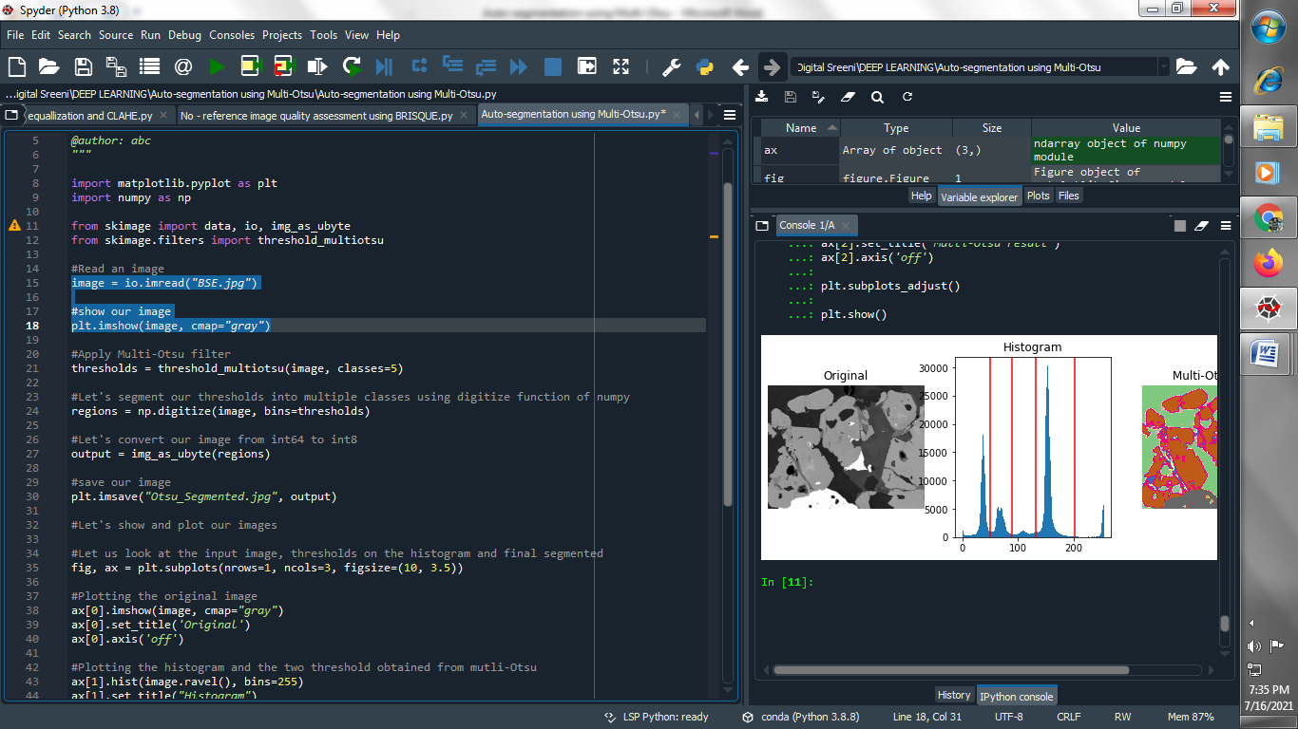

**Output :**

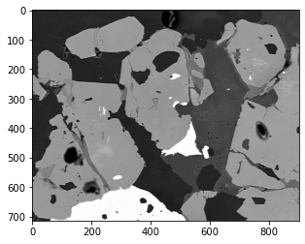

**(2) Apply Multi-Otsu filter :**

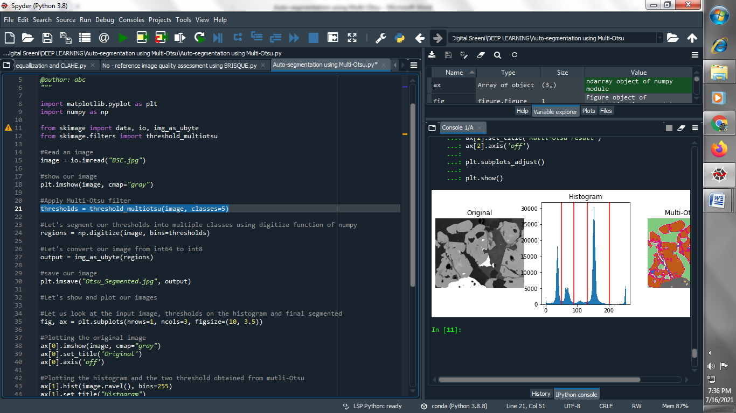

**(3) Let's segment our thresholds into multiple classes using digitize function of numpy :**

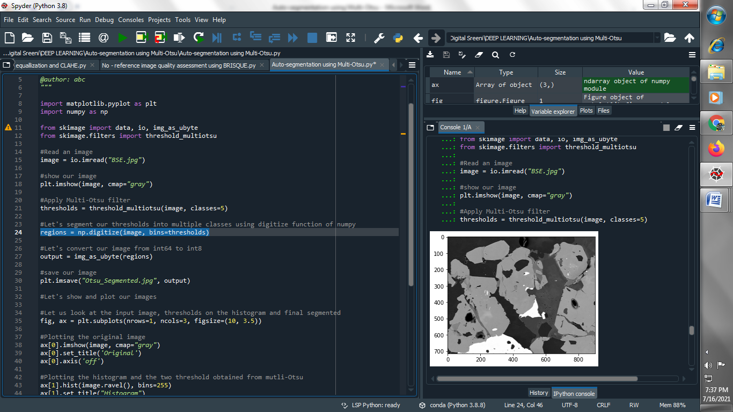

**(4) Let's convert our image from int64 to int8 :**

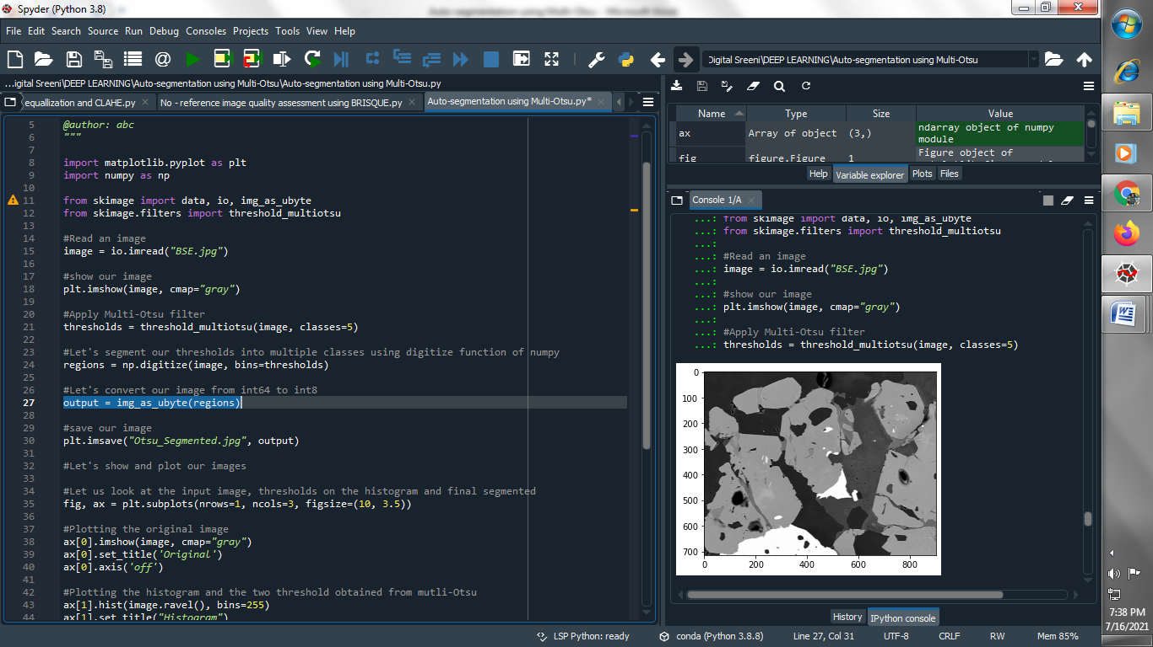

**(5) Save our image :**

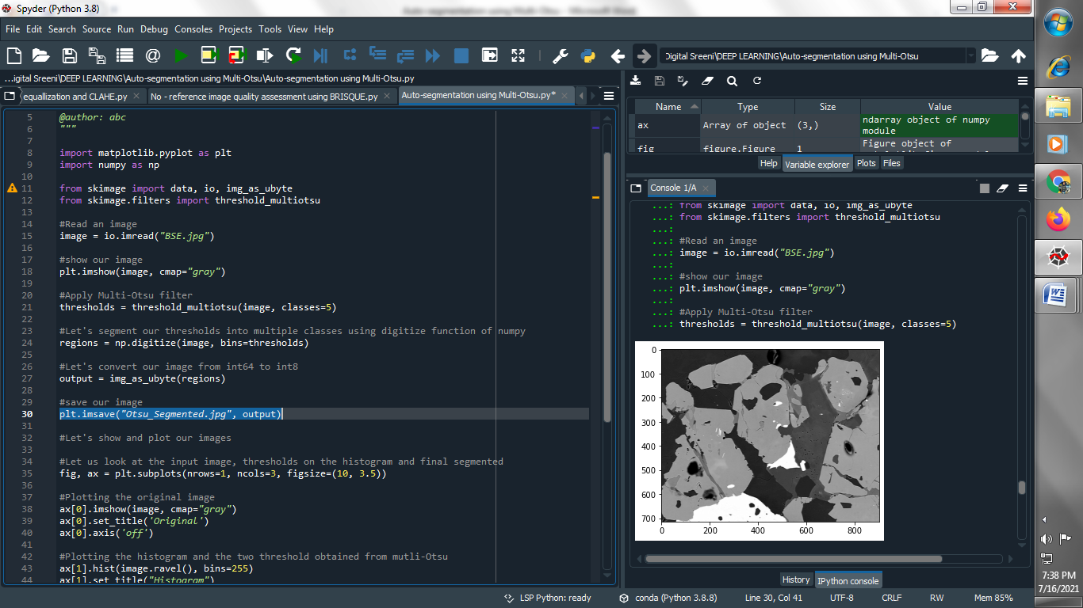

**(6) Let's show and plot our images and Let us look at the input image, thresholds on the histogram and final segmented :**

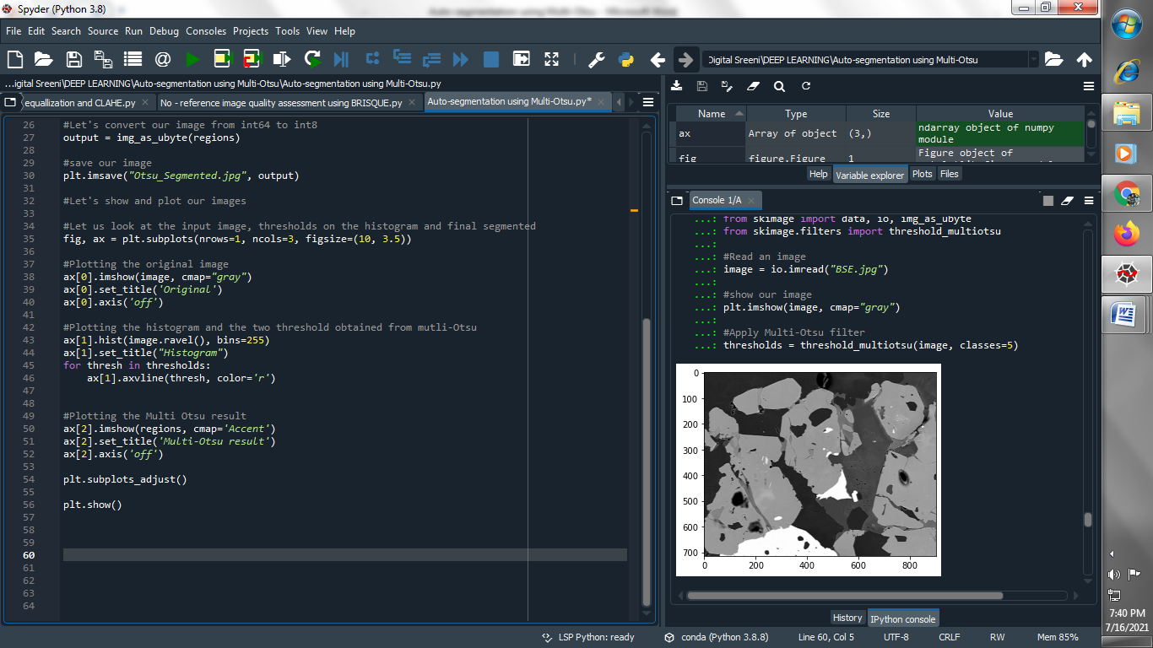

**Output :**

**Original image :**



**Otsu_Segmented image :**

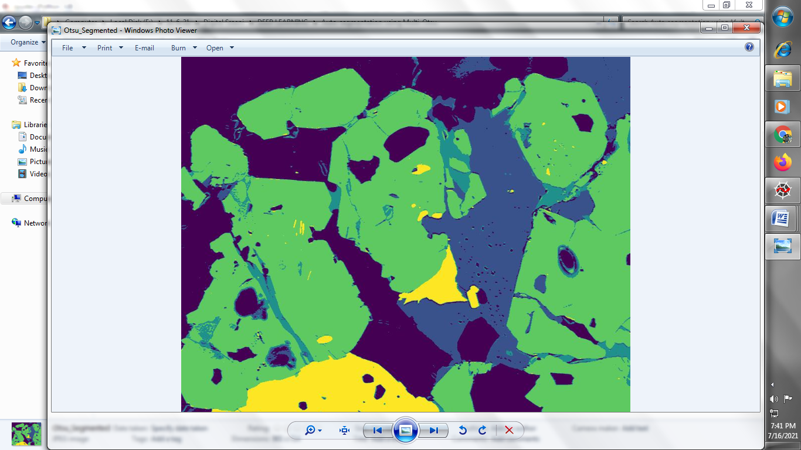

**Plot and histogram the image :**

